Good News! Via de Cristo
EMail to:
Good News! Via de Cristo
Registrar@gnvdc.org e-mail
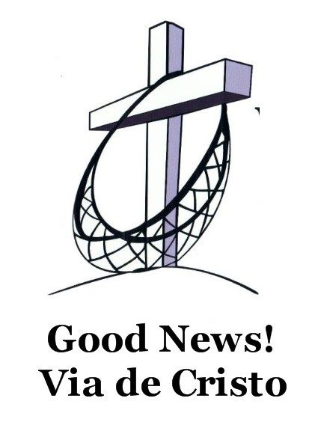
Participant Application

Mission statement: By grace, with the help of the Holy Spirit, we challenge leaders to discover and achieve their personal calling, assisting them with a method for influencing their environment!

PLEASE TYPE OR PRINT CLEARLY
Participant Section
Weekend:  Spring  Fall Year ______
Name _______________________ __________________________ Age _______
First Last
First name, or nickname for your nametag _______________________

Address_____________________________________________________________
Street City State Zip
Home phone: (____) _________________ Work Phone (____) ________________
Emergency Phone: (____) _____________ Contact Name:____________________
Occupation ___________________ E-mail Address _________________________
Gender:  Male  Female Marital Status:  Married  Single  Widowed
If married, name of spouse: ______________________
Has anyone in your family attended a Via de Cristo, Cursillo, or similar weekend? ___
If yes, who?_______________________________ When? _______________
What is your home congregation, including city, state and phone number?: ____________________________________________________________________
______________________________________________ (____) _______________
Do you have any special physical, medical, sleeping or dietary needs that we need to accommodate? (We ask that dietary requests be for medical necessity only) ______
____________________________________________________________________
__________________________________________________________
Sleeping Arrangements:  Supplied cot  I will bring own cot or air mattress
As a Via de Cristo participant, I agree to:
1) pray for myself and other participants prior to the weekend
2) involve myself as I am best able during the weekend and
3) consider joining a Reunion Group & participating in other post-weekend activities.

Signature: ____________________________________ Date: _____________

sponsor Section To be completed by the sponsor
Are you in a reunion group currently?  Yes  No
Name _______________________________________________________________________________
First Last
Address_____________________________________________________________________________
Street City State Zip
Home phone: (____) _________________ Work Phone (____) ________________

E-mail address: (optional): _____________________________________
As a sponsor, I agree to pray, care, help and support my participant before, during, and after the weekend. I understand that this will include at least:
1) prayer for my participant
2) coordination of Palanca letters from the participant’s family and friends
3) transportation to and from the weekend
4) information needed to process this application
5) assistance in helping the participant join a Reunion Group following the weekend
6) encouragement for the participant to return to his / her home congregation with a renewed spirit.
Signature: ____________________________________ Date: _____________

pastor’s Section To be completed and signed by pastor.
Name _____________________________________________________________
First Last
Since the Weekend is designed to help leaders of the Church grow spiritually so that they are able to be more effective servants within the church, we ask that participants and sponsors discuss attending Via de Cristo weekends with their pastor.
❑ I am aware that my parishioner will be attending a Via de Cristo weekend.
❑ I am willing to take some time following the weekend, to discuss the participant’s experience
and how it might enhance congregational life.
❑ I would like additional information about Via de Cristo.
Comments: __________________________________________________________________________
____________________________________________________________________________________
Signature: ____________________________________ Date: _____________

What is Via de Cristo?

Via de Cristo, pronounced BEE-ah de KREES-toe, meaning, “The Way of Christ”, is a short course in Christianity. It is a three day seminar which takes a New Testament look at Christianity as a lifestyle. It is a highly structured weekend for CHRISTIANS, designed to examine true faith and , through it, help Christians positively impact their environment. Via de Cristo is presented as a combined effort of laymen and clergy.

Purpose of Via de Cristo
Can Christianity penetrate all of the different areas of our daily lives? Can it grow there? Can it transform the world? “You are the light of the world…Let your light shine before men that they may see your good works and give glory to your Father in heaven”. (Matthew 5:14 and 16) Via de Cristo is intended to help Christians be “the light of the world”. It proposes NO NEW TYPE OF CHRISTIANITY. It is not a church, but it does simply present a means through which one’s grace-filled life may be daily lived and shared with others in a natural and loving way. Via de Cristo is designed to help strengthen and renew a Christian’s faith, thereby helping the individual to share their faith within their families, congregations and the environments where they live and work.

Via de Cristo Follow Through
You may attend a Via de Cristo only ONCE in your life, but you are asked to build on it for the rest of your life. Via de Cristo is NOT A RETREAT or a substitute for a retreat. Later retreats do, however, complement it. The subsequent activity is known as the Fourth Day. This is actually the rest of your life.

Those attending are asked to do two things in the Fourth Day: 1. expand their inner spiritual life through study and church participation, and 2. become more active witnesses for Christ in their daily lives. Via de Cristo offers two ongoing means of perseverance: 1. ULTREYA, meetings of the local community for encouragement and study, and 2. GROUP REUNIONS, small groups of men or women who meet regularly for a short period to help one another in their quest for spiritual development. Participation in these two groups is a voluntary part of Via de Cristo and is strongly encouraged.

History of Via de Cristo
Originating as Cursillo®, Spanish for “short course”, in the Spanish Catholic Church in the late 1940’s, it came into America in the late 1950’s. The movement began in the Lutheran church when laity and clergy, both in Iowa and Florida, attended Catholic Cursillos® in 1971. The first Lutheran-sponsored weekends began independently early in 1972 in both Iowa and Florida. Since that time, the movement has spread to many states across the nation. In 1985, the name Via de Cristo was selected to recognize this movement’s ecumenical character.

What Happens At Via de Cristo?
Via de Cristo begins on Thursday night and ends on the following Sunday night. During the three days, participants live and study together with singing and prayer. Via de Cristo is centered around 14 talks, with five given by clergy and nine by laity. Following each talk, small roundtable discussions focus on the main points of the talk. The talks, in an overlapping fashion, present the Christian life, based on the person and teachings of JESUS CHRIST, as an Ideal. Via de Christo gives those attending a living understanding of basic Christian truths.

Who Should Go On A Via de Cristo?
Via de Cristo is for Christians who seek more joy, purpose and meaning in their faith. It is for those who desire to grow in their faith and learn more about prayer, Bible study and sharing their faith with others.

In the case of married individuals, both husband and wife are encouraged to attend a Via de Cristo to strengthen their relationship as one in Christ Jesus. It is strongly recommended that the husband and wife attend the same set of weekends. If that is not possible, the husband should attend first.

Jesus said, “You are the branches…” John 15:1-11

